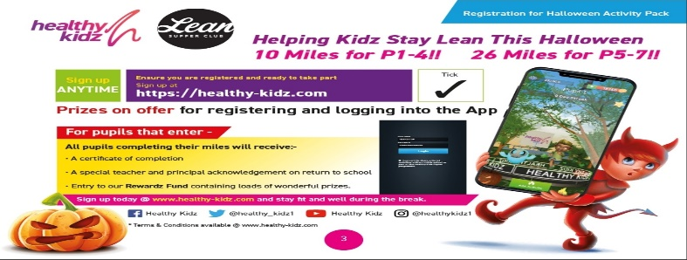

Free Halloween Activity Pack and Virtual Buddy App Access For All pupils - See info below from Healthy Kidz

In partnership with Lean Supper Club
We are ‘Helping Kidz Stay Lean This Halloween’ with a bundle of FREE RESOURCES including exciting challenges and activities to keep kidz active and entertained this Halloween break!
We were here the first time round, and you bet we’re here again! Over 20,000 healthy kidz took part in our virtual sports day in June, and we expect nothing less this time round!
Access the resources (+ our Virtual Buddy App) and learn how to log the activities by following the link below specific to your child’s primary group:

https://tinyurl.com/HKPrimary1

https://tinyurl.com/HKPrimary2

https://tinyurl.com/HKPrimary3

https://tinyurl.com/HKPrimary4

https://tinyurl.com/HKPrimary5

https://tinyurl.com/HKPrimary6

https://tinyurl.com/HKPrimary7

https://healthy-kidz.com/halloween-activity-pack/

Sign up now for FREE via our website https://healthy-kidz.com/halloween-activity-pack/ to join in on our ‘Helping Kidz Stay Lean This Halloween’ activities
#halloweenactivities #kidzactivities #runthegauntlet #homelearninglessons #mindfulness #prizes #leansupperclub

www.healthy-kidz.com

